**Classification of Cardiorespiratory Diseases and their Intensity using Patient Respiratory Sounds to Manage Patient Readmissions**

Aoya Natalie Akoth

121600

ICS 4 B

Supervisor Name

Tiberius Tabulu

Submitted in Partial Fulfilment of the Requirements of the Bachelor of Science in Informatics and Computer Science at the School of Computing and Engineering Science

Strathmore University

Nairobi, Kenya

September 2022

Declaration and Approval

I declare that this work has not been previously submitted and approved for the award of a degree by this or any other University. To the best of my knowledge and belief, the research proposal contains no material previously published or written by another person except where due reference is made in the research proposal itself.

Student Name: Aoya Natalie Akoth

Admission Number: 121600

Student Signature: _________________________ Date: ________________________

The Proposal of **Aoya Natalie Akoth** has been reviewed and approved by **Tiberius Tabulu**

Supervisor Signature: _________________________ Date: ________________________

Acknowledgement

Abstract

Recently, cardiorespiratory diseases have become an escalating health issue worldwide. The increase in these diseases has been brought about by exposure to pollutants such as airborne particulate matter. Patients with cardiorespiratory diseases tend to exhibit ARS such as crackles and wheezes, which are used as a basis for diagnosis of such diseases. Misdiagnoses by inexperienced clinicians almost always result in patient readmissions and in some cases pose a threat to patients’ lives.

One of the leading causes of readmissions worldwide is the misdiagnosis of diseases, especially for diseases related to respiration. They result in a significant burden on medical facilities in terms of increased cost and mortality rates. To overcome patient readmission limitations, the developed solution aimed at classifying cardiorespiratory diseases together with the level of intensity of the disease. The methodology that was used was Design Thinking Methodology.

The solution used a web application to receive input from physicians and give them output from the model. The output included the level intensity of the disease together with the disease classification. The developed solution was focused on complementing the inaccuracies of clinicians’ auscultation, and it aided in the management of patient readmissions due to symptom exacerbations and misdiagnoses by physicians.

Table of Contents

Declaration and Approval ii

Acknowledgement iii

Abstract iv

List of Figures viii

List of Abbreviations ix

Chapter 1: Introduction 1

1.1 Background Information 1

1.2 Problem Statement 2

1.3 Objectives 2

1.3.1 General Objective 2

1.3.2 Specific Objectives 2

1.4 Research Questions 3

1.5 Justification 3

1.6 Scope and Delimitations 3

1.6.1 Scope 3

1.6.2 Delimitations 3

1.7 Limitations 4

Chapter 2: Literature Review 5

2.1 Introduction 5

2.2 A Review of The Current State of Respiratory Sound Analysis in the World 5

2.2.1 Challenges Experienced in Computerized Lung Sound Analysis 6

2.3 Algorithms That Support the Classification of ARS and Cardiorespiratory Diseases 6

2.3.1 Artificial Neural Networks 6

2.3.2 K-Nearest Neighbor 6

2.4 Existing Models Used in The Classification of Cardiorespiratory Diseases 7

2.4.1 An Embedded Classifier of Lung Sounds Based on The WPT And ANN 7

2.4.2 Analysis of Adventitious Lung Sounds Originating from Pulmonary TB 7

2.4.3 Classification of Lung Sounds Using CNNs 8

2.5 Conceptual Framework 8

Chapter 3: Methodology 10

3.1 Introduction 10

3.2 Applied Methodology 10

3.2.1 Empathize 10

3.2.2 Define 11

3.2.3 Ideate 11

3.2.4 Prototype 11

3.2.5 Test 11

3.3 System Analysis 12

3.3.1 Approach to Design and Development 12

3.3.2 Use-Case Diagram 12

3.3.3 Sequence Diagram 12

3.3.4 System Sequence Diagram 12

3.3.5 Entity Relationship Diagram 13

3.3.6 Class Diagram 13

3.3.7 Activity Diagram 13

3.4 System Design 13

3.4.1 Database Schema 13

3.4.2 Wireframes 13

3.4.3 System Architecture 13

3.5 Tools and Techniques Used 14

3.5.1 Python 14

3.5.2 Kaggle 14

3.5.3 GitHub 14

3.6 System Deliverables and Milestones 14

3.6.1 Concept Defense 14

3.6.2 Proposal Document 14

3.6.3 Analysis and Design Diagrams Document 15

3.6.4 Working Prototype 15

Chapter 4: System Analysis and Design 16

4.1 Introduction 16

4.2 System Requirements 16

4.2.1 Functional Requirements 16

4.2.2 Non-functional Requirements 17

4.3 System Analysis Diagrams 17

4.3.1 Use Case Diagram 18

4.3.2 System Sequence Diagram 18

4.3.3 Sequence Diagram 19

4.3.4 Entity Relationship Diagram 20

4.3.5 Class Diagram 21

4.3.6 Activity Diagram 22

4.4 System Design Diagrams 22

4.4.1 Database Schema 23

4.4.2 Wireframes 23

4.4.3 System Architecture 24

Bibliography 26

Appendix 30

Appendix 1: Gantt Chart 30

List of Figures

Figure 2.1 Conceptual Framework 9

Figure 3.1 Design thinking methodology (Adopted from(Steinke et al., 2017)) 10

Figure 4.1 Use Case Diagram 18

Figure 4.2 System Sequence Diagram 19

Figure 4.3 Sequence Diagram 20

Figure 4.4 Entity Relationship Diagram 21

Figure 4.5 Class Diagram 22

Figure 4.6 Activity Diagram 22

Figure 4.7 Database Schema 23

Figure 4.8 Registration and Login Pages 23

Figure 4.9 Input Page 24

Figure 4.10 Output Page 24

Figure 4.11 System Architecture 25

List of Abbreviations

ANN – Artificial Neural Network

ARS – Adventitious Respiratory Sounds

CNN – Convolutional Neural Network

DFD – Data Flow Diagram

ERD – Entity Relationship Diagram

GOLD – Global Initiative for Chronic Obstructive Lung Disease

KNN – K-Nearest Neighbor

MFCC – Mel Frequency Cepstral Coefficient

OOAD – Object Oriented Analysis and Design

STFT – Short-Time Fourier Transform

TB – Tuberculosis

WHO – World Health Organization

WPT – Wavelet Packet Transform

# Introduction

## Background Information

Cardiorespiratory diseases are a wide range of serious disorders that affect the heart and lungs. According to WHO, cardiorespiratory diseases are the third leading cause of death worldwide. These diseases cause a significant health and socioeconomic burden on health systems (Gibson et al., 2013). Therefore, in the last decade, significant research efforts have been dedicated to improving early diagnosis and routine monitoring of patients with cardiorespiratory diseases to allow timely interventions(Marques et al., 2014).

According to Barzegari et al., (2017), one of the leading causes of readmissions is misdiagnosis of diseases. Readmissions are preventable when artificial intelligence is introduced to complement medical decisions made during diagnosis. The occurrence of readmissions is often an indicator of deficient quality of health services(Ramírez & Herrera, 2019). Readmissions cause a burden on medical facilities in terms of increased cost and mortality rates, therefore efforts by medical experts are made to reduce them(Brunner et al., 2020).

Patients suffering from cardiorespiratory diseases exhibit ARS as one of the main symptoms. ARS are respiratory sounds superimposed on normal respiratory sounds, which can be discontinuous such as crackles or continuous such as wheezes. They usually occur over the lungs and airways and play an important role in indicating the respiratory health of an individual. These sounds have been validated as an objective, simple, and noninvasive marker to check the respiratory system(Jácome & Marques, 2015).

The stethoscope has always been considered an indispensable diagnostic tool especially when it comes to auscultations, but it suffers from limitations that need to be avoided to manage the number of readmissions due to cardiorespiratory diseases. Chest auscultation is an essential part of the respiratory examination and is helpful in diagnosing various disorders. The auscultation process is heavily reliant on the presence of adventitious sounds produced when breathing(Perna & Tagarelli, 2019).

There is therefore a need to use a standardized and automated method to detect and classify cardiorespiratory diseases. Introducing artificial intelligence to the auscultation process can help with early detection of cardiorespiratory diseases and identify patients in need of emergency treatment(Kim et al., 2021). The developed solution was focused on giving the level of intensity of the disease together with the diagnosis so that patients can receive the right treatment, therefore leading to managed patient readmissions. At the end, the developed solution was able to complement the inaccuracies of clinicians.

## Problem Statement

The conventional auscultation suffers from three main disadvantages. Firstly, it can become a bottleneck when there is a disproportionate number of practitioners compared to the overall population because for each patient, a medical professional is required to give a diagnosis based on adventitious lung sounds. Secondly, there is dissimilarity in the interpretation of the adventitious sounds by different medical professionals(Acharya & Basu, 2020). Lastly, accurate interpretation of respiratory sounds requires a clinician’s considerable expertise, so trainees such as interns and residents sometimes misidentify respiratory sounds(Kim et al., 2021). When patients suffering from cardiorespiratory diseases are misdiagnosed, they are likely to be readmitted due to symptom exacerbations(Brunner et al., 2020).

The developed solution aimed at classifying the respiratory sounds and giving the level of intensity of the disease. The output of the model was a disease diagnosis and the level of intensity the disease is in, using the GOLD standard. The respiratory sound data was visualized to Mel-Spectrograms, where appropriate features were selected, then a CNN was used in the classification of cardiorespiratory diseases. Through the output of the model, the number of patient readmissions was managed because necessary treatment was assigned to the patients based on the level of intensity of the disease.

## Objectives

### General Objective

To develop a neural network model to be used in the classification of cardiorespiratory diseases and giving the level of intensity of the disease.

### Specific Objectives

1. To review the current state of respiratory sound analysis in the world.
2. To investigate algorithms used in the detection and classification of ARS and cardiorespiratory diseases.
3. To review the existing models used in classification of ARS and cardiorespiratory diseases.
4. To develop a neural network model to be used in the classification of cardiorespiratory diseases and giving the level of intensity of the disease.
5. To test and validate the developed neural network model

## Research Questions

1. What is the current state of respiratory sound analysis in the world?
2. What are the some of the algorithms used in the detection and classification of ARS and cardiorespiratory diseases?
3. What are the existing models used in the classification of ARS and cardiorespiratory diseases?
4. How will the proposed solution be designed and developed?
5. How will the solution be tested and validated?

## Justification

The detection and classification of ARS and cardiorespiratory diseases is a growing field, with many solutions focused on using deep learning algorithms. The study by Basu & Rana,(2020) is focused on using a five-layer neural network in classifying the diseases and giving the correct diagnosis while the study by Acharya & Basu,(2020) introduced patient-specific model tuning to improve the model’s performance. From the existing solutions, patients are still prone to hospital readmissions because the models focus on classification of the cardiorespiratory diseases without giving the level of intensity of the disease.

The developed solution was necessary as it provided both disease classification and the level of intensity of the disease as outputs. The correct treatment was given to patients depending on the level of intensity of the cardiorespiratory disease they had, therefore guaranteeing the management of hospital readmissions due to misdiagnoses and symptom exacerbations.

## Scope and Delimitations

### Scope

The study was focused on identifying ARS from the respiratory sound dataset, classifying the sounds to the corresponding disease and giving the level of intensity of the disease. This helped complement clinicians’ decisions during treatment because appropriate treatment was given depending on the level of intensity of the disease the patient was suffering from.

### Delimitations

The study did not cover managing patient readmissions due to regular checkup and due to other diseases other than previous diagnosis during index hospitalizations. Effects of medications on the diagnosis of diseases was also not covered in this study.

## Limitations

A patient’s diagnosis is often affected by diseases occurring together, this affected the accuracy of the model in cases where there was an occurrence of two diseases. The dataset was only limited to 126 patients, with 920 recording thus not giving an accurate overview of the different levels of disease intensity when training of the model. The study was also limited to the number of cardiorespiratory disease data available in the dataset.

# Literature Review

## Introduction

This chapter aims at reviewing the current state of respiratory sound analysis in the world together with the challenges that are currently being faced. Algorithms used in the detection of ARS will be discussed, and the advantages and disadvantages of using those algorithms will also be mentioned. The existing models used in the detection and classification of ARS and cardiorespiratory diseases will also be reviewed. Finally, a brief overview of the conceptual framework will be discussed, with an accompanying diagram.

## A Review of The Current State of Respiratory Sound Analysis in the World

Chest auscultations are an inexpensive method used in detection of breathing anomalies. Auscultation provides direct information on lung function because pathological abnormalities in the lungs produce distinct sounds(Kandaswamy et al., 2004). The conventional auscultation method of using a stethoscope has many limitations, subjectivity of the physician during diagnosis being the main limitation(Acharya & Basu, 2020).

The study by Pramono et al.,(2017) has inclusively discussed other limitations of the conventional lung auscultation. These limitations include the need for the presence of an expert during auscultations, which can be limiting when an emergency auscultation needs to be performed. Auscultations also need to be performed in a quiet environment, with the patient being in a still position. Finally, the human auditory system is also a limitation when using the stethoscope for auscultations. These limitations therefore led to the development of computerized lung sound analysis.

Computerized lung sound analysis entails using an electronic equipment to record the patient's lung sounds, followed by computer analysis and classification of the sounds based on certain signal characteristics(Gurung et al., 2011). Computerized systems for recording and analyzing lung sounds have overcome many of the limitations of simple auscultation over the last 30 years(Kandaswamy et al., 2004). This can be seen clearly by the advantages offered by this system.

Automated respiratory sound classification has the ability to detect anomalies in the early stages of respiratory dysfunction, therefore improving effectiveness of decision-making(Rocha et al., 2018). Another advantage is that the use of computers to research lung sounds has numerous advantages in terms of sound storage, processing, and visualization of respiratory sounds in computers(Rocha et al., 2020). The use of electronic stethoscope in analyzing lung sounds also offers the advantages of volume adjustment, reduction of heart sounds, recording and transmitting wirelessly to a computer.

### Challenges Experienced in Computerized Lung Sound Analysis

Even though the computerized lung sound analysis offers many advantages, it still suffers from challenges affecting its performance. One of the limitations of using lung recordings is the presence of ambient noise in the recordings(Emmanouilidou et al., 2018). Without filtering the noise, it will be hard to detect the adventitious sounds.

Another important issue discussed by Khan (2012), is the lack of vastness in the data used in the computerized lung sound analysis systems. Only a few researchers used data from hospitals, while the majority used data from lung sound CDs that were used to train doctors and nurses. This can be limiting because machine learning models require larger datasets for training the model.

## Algorithms That Support the Classification of ARS and Cardiorespiratory Diseases

There are many algorithms used in the classification of ARS and cardiorespiratory diseases, but only 2 are the most used. The most used algorithms are ANN and KNN algorithms because of their performance(Palaniappan et al., 2013). Other uncommonly used algorithms include Support Vector Machine, Gaussian Mixture, Random Forest, Hidden Markov, Logistic Regression, Edge Detection on Spectrogram Image and finally Discriminant Analysis(Pramono et al., 2017).

### Artificial Neural Networks

The goal of Artificial Neural Networks is to imitate the behavior of biological neural networks. The study by Tocchetto et al.,(2014), used WPT in signal processing for feature extraction. The features were then fed into the ANN for classification into three categories, one normal and two pathological. An accuracy of 98.89% for Symlet-10 wavelet base on the test set was achieved. An advantage of ANN is it can adapt well to complex non-linear data and classifying it accurately and effectively.

### K-Nearest Neighbor

The study by Abdullah et al.,(2017), first filtered the audio files using a band pass filter, then used entropy as the suitable feature. These features were fed into a KNN classifier with a k-value of 9 and this reported an accuracy of 89.33% for non-smokers and 78.67% for smokers. The advantages of KNN include its simplicity and robustness. It can also distinguish between normal and abnormal respiratory sounds.

Despite the advantages provided by using ANN and KNN classifiers, they still suffer from the disadvantage of a computational burden caused by training the model. The requirement for a very large dataset to train the model to accurately recognize lung sounds is also another disadvantage(Palaniappan et al., 2013).

## Existing Models Used in The Classification of Cardiorespiratory Diseases

This study focused on models that used ANN and KNN in the classification process of ARS and cardiorespiratory diseases. The study by Pramono et al.,(2017) gives a summary of existing models used in the classification of ARS and cardiorespiratory diseases and they include:

### An Embedded Classifier of Lung Sounds Based on The WPT And ANN

In the study by Tocchetto et al.,(2014), a total of 92 lung sounds were recorded, including 27 normal, 31 crackles, and 34 wheezes. As part of the training process, 60 sounds were used to train the ANN, 7 for testing and 7 for validation. The remaining 18 sounds in the database were used to evaluate the trained ANN's performance. A WPT was used to decompose lung sound signals into frequency sub-bands, and a set of statistical features was extracted from the sub-bands to represent the distribution of wavelet coefficients. The features were fed into an ANN which classified respiratory sounds into three categories: normal, wheezes and crackles. The classifier achieved a best average accuracy of 98.89% for Symlet-10 wavelet base on the test set.

The gap in this model is that only the events of an ARS were recorded, and the diagnosis of a potential cardiorespiratory disease was not given. Due to this, patients are likely to go back to hospitals due to symptom exacerbations of a particular disease for example asthma.

### Analysis of Adventitious Lung Sounds Originating from Pulmonary TB

The study by Becker et al.(2013), tried to demonstrate the value of computer-aided auscultation in the diagnosis and treatment of tuberculosis. Respiratory sounds were recorded from 14 different locations on the posterior and anterior chest walls of 60 healthy volunteers and pulmonary tuberculosis patients. The statistical overlap factor was used to identify the most significant signal features associated with the presence of TB in both the time and frequency domains. These features were then used to train a neural network to automatically categorize the auscultation recordings as healthy or TB-origin. The neural network had a diagnostic accuracy of 73%.

Despite the advantage of giving the diagnosis of TB patients, the model’s accuracy could be improved by filtering out the noise from the clinics and using more training samples.

### Classification of Lung Sounds Using CNNs

The study by Aykanat et al.(2017), a total of 17,930 lung sounds from 1630 subjects were recorded. MFCC features in a support vector machine was used to benchmark using spectrogram images in the CNN. To classify respiratory audio, CNN and SVM algorithms were used in the following ways: healthy versus pathological classification achieved an accuracy of CNN 86%, SVM 86%. Rale, rhonchus, and normal sound classification achieved an accuracy of CNN 76%, SVM 75%, singular respiratory sound type classification achieved CNN 80 %, SVM 80% accuracies and audio type classification with all sound types achieved CNN 62%, SVM 62% accuracies. From the results, they found out that the CNN algorithm for spectrogram image classification works just as well as the SVM algorithm.

Despite the good accuracies achieved, the model only focused on classifying respiratory sounds to either be normal or adventitious. Disease diagnosis was not given, together with the level of intensity of the disease, therefore patients are still susceptible to readmissions due to symptom exacerbations.

## Conceptual Framework

The developed solution aimed at working in the following way: Physicians recorded respiratory sounds using electronic stethoscopes. These recordings were stored in a database and were used as inputs to the web application. The developed model was in the backend and worked by filtering the audio files to remove any ambient noise using a band pass filter, then they were converted to Mel Spectrograms, which was used for feature extraction. Finally, from the features extracted, CNN algorithm was used in classification of the diseases. The output of the model was displayed to the physician through a web application. This framework can be seen in Figure 2.1

Figure 2.1 Conceptual Framework

# Methodology

## Introduction

This chapter talks about the methodology that has been selected for the proposed solution. The chapter also explains the steps followed in the methodology and how they will be applied in the solution together with the approach to be used for design and development. The methodology selected for the developed solution was Design Thinking Methodology.

## Applied Methodology

Design thinking methodology is an innovative problem-solving process that helps companies to come up with a desired outcome on a specific problem (Steinke et al., 2017). The reason for selecting this methodology is because it is an iterative process hence allowing one to go back to a previous step in case of any needed changes and because it will help in coming up with innovative solutions to get the desired outcome. The diagram for the methodology is shown in Figure 3.1

Figure 3.1 Design thinking methodology (Adopted from(Steinke et al., 2017))

### Empathize

This is the process of getting a better understanding of the problem that is to be solved. The goal of this phase was to collect requirements by better understanding the users' experiences.

#### Researching User Needs

This phase was focused on gaining insight into users and their needs. Medical documents and research papers were analyzed to discover opportunities to meet new user needs that were lacking in existing cardiorespiratory disease classification systems. This helped get a better understanding of the problem that was to be solved.

### Define

In this stage, all the information gained through the empathize stage were put together to bring focus to the parameters of the issue. The goal of this phase was to conclude with a requirement statement that clearly defined the scope and parameters of the problems. The data collected from secondary documents were analyzed and organized to better concrete the problems defined. This helped gather great ideas and in understanding how to use them effectively.

### Ideate

This phase consisted of generating different possibilities that could be potential solutions to previously defined problems, or at least a portion of a solution to the proposed challenge. Different solutions to the problem were generated through brainstorming and this allowed for more innovative solutions to normalized problems. A system analysis of the proposed solution was also done in this stage as seen in section 3.3.

### Prototype

This is an experimental phase. It enables teams to identify flaws in their design thinking process while also allowing them to iterate on their product. An inexpensive product with specific features was created in this phase. The aim was to identify the best possible solution for the problem found.

### Test

The prototype that was created in the previous phase was tested in this step to see how well it solved the problems that were initially analyzed in stages one and two. Alterations and refinements were made to make the product more polished for user needs. With this process, it allowed going back to previous stages and revising the information to get the best outcomes from the model. The testing paradigms that were used are unit and integration testing.

1. **Unit Testing**

The different modules of the model were tested independently, using glass-box mechanism. This is important as it checked if the modules were meeting the requirements set in the initial stages of development.

1. **Integration Testing**

Keras was used to evaluate the performance of the model. This was done by creating a plot of expected results against the results produced by the model.

## System Analysis

### Approach to Design and Development

The approach used in the developed solution is OOAD. It is a technical method of analyzing and designing an application based on that system’s object models. Each object represents some entity of interest in the system being modeled, and is characterized by its class, its state (data elements), and its behavior for example, a physician.

The purpose of the systems analysis phase was to build a logical model of the new system. The analysis tool that was used to draw the diagrams is Visual Paradigm.

### Use-Case Diagram

A use case describes the steps in a specific business function or process. It shows the interaction of things outside the system with the system itself. The various processes within the solution were modelled for example filtering out noise form the audio data. This diagram helped in identifying actors in a specific use-case and the functions they performed on the system.

### System Sequence Diagram

A system sequence diagram is a dynamic model of a use case, showing the interaction among processes during a specified time. A system sequence diagram graphically documents the use case by showing the processes, the messages, and the timing of the messages. This diagram was drawn to visualize how the actors of the system interacted among each other and the system itself.

### Sequence Diagram

A sequence diagram shows the interaction among objects during a specified time. The elements participating in a sequence diagram are objects. The messages exchanged by these elements are method invocations. The sequence diagram was modelled to show various methods of a given class within the system. This diagram helped visualize the interactions between different objects of the system.

### Entity Relationship Diagram

An ERD is a model that shows the logical relationships and interaction among system entities. This was drawn to provide an overall view of the system, the entities, their attributes, and relationships between the system entities and the system itself.

### Class Diagram

A class diagram shows the object classes and relationships involved in a use case. The diagrams were drawn to identify objects that belong to a class and their attributes together with methods that would be invoked.

### Activity Diagram

An activity diagram resembles a horizontal flowchart that shows the actions and events as they occur. Activity diagrams show the order in which the actions take place and identify the outcomes. This diagram was drawn and used to identify actions of the users and the events associated with these actions.

## System Design

### Database Schema

A database schema is an abstract design that represents the storage of your data in a database. The data was organized in form of tables. This schema helped visualize how login details and respiratory sounds would be structured.

### Wireframes

Wireframes are a layout of a screen’s interface which show how people would use the product. The wireframes were used to illustrate each step of the user’s journey within the developed system to pinpoint possible pitfalls before development starts.

### System Architecture

System architecture translates the logical design of an information system into a physical structure that includes hardware, software, network support, processing methods, and security. This gave a brief overview of the developed system, therefore was used to envision all components and their interaction with the system.

## Tools and Techniques Used

### Python

The programming language that was used to develop the proposed solution is python, which is high-level and best suited for machine learning projects. Libraries within python that were used include:

1. **Librosa**

This is a python package for audio and music analysis. It was used for feature extraction from the audio data.

1. **Matplotlib**

This is a library used to create static, animated and interactive visualizations in python. It was used for data visualization of the Mel spectrograms.

1. **Keras**

This python library provides an interface for artificial neural networks This library will be used to construct the CNN model, with TensorFlow in the backend.

### Kaggle

The dataset that was used to train and test the model was retrieved from Kaggle. The dataset was split using k-fold cross validation for training and testing, in order to increase the size of the dataset.

### GitHub

This online collaboration tool was used to store the code and act as a backup in case of any system failures in the future.

## System Deliverables and Milestones

### Concept Defense

The concept note is a summary of the general idea of the product to be developed. The presentation was prepared, and the idea presented before a panel for approval.

### Proposal Document

A System Proposal is a document which is presented to get project approved. This document was needed because it defined the objectives of the developed solution as well as the steps that were followed during development.

### Analysis and Design Diagrams Document

This is the document that contains all diagrams of the system design and architecture of the approach chosen. The diagrams were drawn to visualize the whole system and its processes.

### Working Prototype

1. **Authentication Module**

Authentication is the process of identifying the identity of a user. This includes registration and login. Registration is when a user input their details to create an account for the first time and login is when a user inputs their username together with their passwords. This module was needed for security purposes for the physicians.

1. **Filtered Audio Recordings**

A band pass filter was used to filter out any noise outside of certain frequencies, this ensured more accurate results for diagnosis.

1. **Extracted Features**

Mel Spectrograms were used to extract features from the filtered respiratory sound recordings. These features were used to train the CNN model to be built.

1. **CNN Model**

A CNN model to be used for classification was built. Classification was also based off severity of the ARS from the features extracted.

1. **Patient Diagnosis Module**

In this module, the patient diagnosis was produced as a product of the trained CNN model. The disease classification together with the severity of the disease was given so that the correct treatment would be given to the patient depending on their level of exacerbation.

1. **Model Test Cases**

The system was tested to verify that all the system objectives were met. The testing paradigms that were used are unit and integration testing.

# System Analysis and Design

## Introduction

In this chapter, the functional and non-functional requirements of the system will be described in detail. The system analysis and system design diagrams will also be drawn and described while observing the development approach previously selected in Chapter 3:, which was OOAD.

## System Requirements

Some of the system requirements reviewed in the project include:

### Functional Requirements

Functional requirements define what the system is expected to do. These include:

1. **Authentication**: This is the plug-in that collects user information and compares this information against the users’ information in the database, that is, registration and login. This was done by creating registration and login pages for the physician, and the information collected included the full name, email address and password. During login, the only details used were email address and the password.
2. **Send Respiratory Sound Input to Model:** This is the module that takes the respiratory sound recording and patient id as input from the physician and sends it to the model for classification. It was done by adding an upload button in the web application that only receives audio files and connecting the web application to the model in the backend.
3. **Data Pre-Processing:** This is the module of the model that filters out any ambient noise from the respiratory sound recordings so that it does not affect classification in later stages and saves the filtered recording in the database for analysis. It was done by using a band pass filter that only allows a range of a specified frequency to pass through. The respiratory sound recording was saved using the patient id for easy identification.
4. **Feature Extraction:** This is the module of the model that receives the filtered respiratory sound and uses a Mel-Spectrogram to extract features to be used in the neural network for classification. This was done by converting the respiratory sound to a Mel-Spectrogram and extracting the required features to be used in disease classification. This module then sent the extracted features to the CNN.
5. **Classify Cardiorespiratory Diseases and The Level of Intensity of the Disease:** This is the module of the model that uses a CNN to classify the cardiorespiratory disease and the level of intensity of the disease. It was done by developing a CNN model that takes in extracted features from the Mel-Spectrogram and classifies the disease that the patient might be suffering from together with the level of intensity of that disease. This module then sends its output to the web application.
6. **Display The Output of The Model:** This is the module that displays the output of the model to the physician through the web application. It was done by using text boxes on the display with the disease classification and the level of intensity of the disease.

### Non-functional Requirements

Non-functional requirements are the desirable attributes of a system that make it interactive and user-friendly, but a system can still function without. These include:

1. **Security:** This is where the system assures that all data inside the system or its part will be protected against malware attacks or unauthorized access. It was implemented by ensuring that only authenticated physicians were allowed to access the system and receive output from the model.
2. **Performance:** This is a system attribute that describes how fast a system needs to operate. The system was developed in a way that ensured a reasonable response time when performing its functions for example immediate success messages on successful actions such as registration. This was implemented by using query-optimization techniques such as only selecting the attributes that were needed from the database, thus a faster response time.
3. **Availability:** This describes how likely the system is accessible for a user at a given point in time. The system was developed in such a way that it was always available to a user if their computer was connected to the internet.

## System Analysis Diagrams

The system analysis diagrams of the developed solution included Use-case diagram, Sequence diagram, System-sequence diagram, Class diagram, Activity diagram and finally ERD. These diagrams are as follows:

### Use Case Diagram

Figure 4.1 shows the use case diagram of the system. The system has two actors, the physician and the classification model. The diagram shows how each actor associates with the system through different use cases.

Figure 4.1 Use Case Diagram

### System Sequence Diagram

Figure 4.2 shows the interaction between the physician and the system itself together with their timings.

Figure 4.2 System Sequence Diagram

### Sequence Diagram

The sequence diagram shows the timing of interactions between actors of the system and the modules of the system as they occur. This is shown in Figure 4.3

Figure 4.3 Sequence Diagram

### Entity Relationship Diagram

Figure 4.4 shows the entities of the system and their relationship with each other. Each entity is assigned an attribute to describe it.

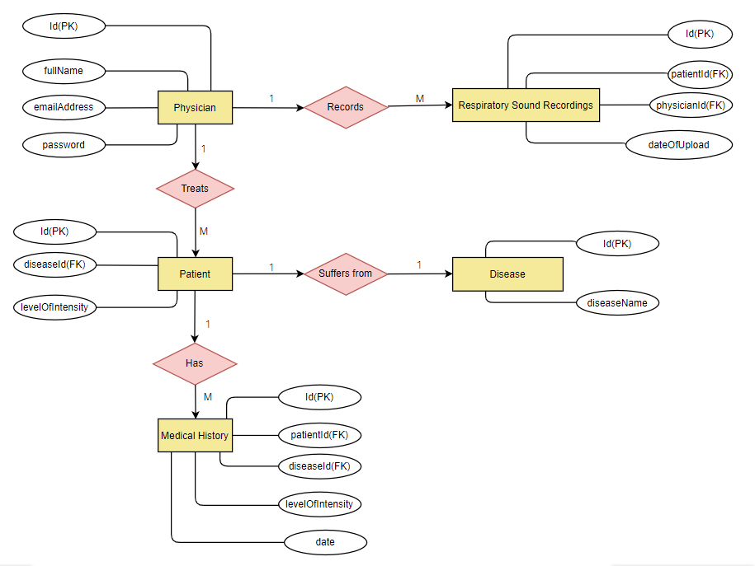

Figure 4.4 Entity Relationship Diagram

### Class Diagram

Figure 4.5 shows the class diagram. The relationships between the classes have been shown using the associations. The classes have attributes and some of them have operations that they perform on the system such as inserting input to the system.

Figure 4.5 Class Diagram

### Activity Diagram

An activity diagram resembles a horizontal flowchart that shows the actions and events as they occur. The diagram drawn shows the order in which the actions take place and identify the outcomes and is shown in Figure 4.6

Figure 4.6 Activity Diagram

## System Design Diagrams

The system design diagrams include Database Schema, Wireframes and System Architecture. These diagrams are as follows:

### Database Schema

The logical database schema of the system is shown in Figure 4.7

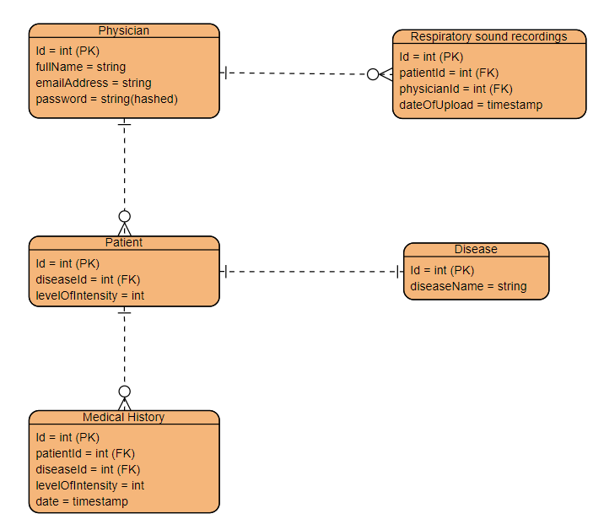

Figure 4.7 Database Schema

### Wireframes

#### Registration And Login Pages

Figure 4.8 shows the system registration and login pages.

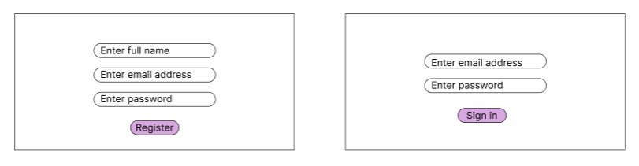

Figure 4.8 Registration and Login Pages

#### Input Page

Figure 4.9 shows the page where the physician is expected to insert the patient id and respiratory sound recording as input for classification.

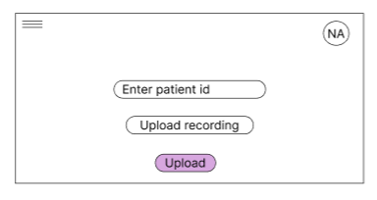

Figure 4.9 Input Page

#### Output Page

Figure 4.10 shows the page where the physician receives output from the model and decides the required treatment for the patient.

Figure 4.10 Output Page

### System Architecture

The system architecture diagram for the developed solution used the three-tier model which includes presentation, application logic and the database as shown in Figure 4.11. The presentation layers display the functionalities of the system in a simplified view.

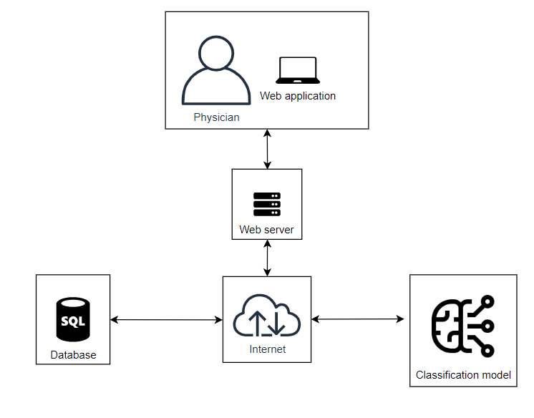

Figure 4.11 System Architecture

Bibliography

Abdullah, N. S., Lam, C. K., Sundaraj, K., & Palaniappan, R. (2017). Classification of Respiratory Sounds in Smokers and Non-smokers using k-NN Classifier. In F. Ibrahim, J. P. G. Cheong, J. Usman, M. Y. Ahmad, R. Razman, & V. S. Selvanayagam (Eds.), *3rd International Conference on Movement, Health and Exercise* (Vol. 58, pp. 73–78). Springer Singapore. https://doi.org/10.1007/978-981-10-3737-5_15

Acharya, J., & Basu, A. (2020). Deep Neural Network for Respiratory Sound Classification in Wearable Devices Enabled by Patient Specific Model Tuning. *IEEE Transactions on Biomedical Circuits and Systems*, 1–1. https://doi.org/10.1109/TBCAS.2020.2981172

Aykanat, M., Kılıç, Ö., Kurt, B., & Saryal, S. (2017). Classification of lung sounds using convolutional neural networks. *EURASIP Journal on Image and Video Processing*, *2017*(1), 65. https://doi.org/10.1186/s13640-017-0213-2

Barzegari, H., Fahimi, M. A., & Dehghanian, S. (2017). Emergency Department Readmission Rate within 72 Hours after Discharge; a Letter to Editor. *Emergency*, *5*(1). https://doi.org/10.22037/emergency.v5i1.16667

Basu, V., & Rana, S. (2020). Respiratory diseases recognition through respiratory sound with the help of deep neural network. *2020 4th International Conference on Computational Intelligence and Networks (CINE)*, 1–6. https://doi.org/10.1109/CINE48825.2020.234388

Becker, K. W., Scheffer, C., Blanckenberg, M. M., & Diacon, A. H. (2013). Analysis of adventitious lung sounds originating from pulmonary tuberculosis. *2013 35th Annual International Conference of the IEEE Engineering in Medicine and Biology Society (EMBC)*, 4334–4337. https://doi.org/10.1109/EMBC.2013.6610505

Brunner-La Rocca, H.-P., Peden, C. J., Soong, J., Holman, P. A., Bogdanovskaya, M., & Barclay, L. (2020). Reasons for readmission after hospital discharge in patients with chronic diseases—Information from an international dataset. *PLOS ONE*, *15*(6), e0233457. https://doi.org/10.1371/journal.pone.0233457

Emmanouilidou, D., McCollum, E. D., Park, D. E., & Elhilali, M. (2018). Computerized Lung Sound Screening for Pediatric Auscultation in Noisy Field Environments. *IEEE Transactions on Biomedical Engineering*, *65*(7), 1564–1574. https://doi.org/10.1109/TBME.2017.2717280

Gibson, G. J., Loddenkemper, R., Lundbäck, B., & Sibille, Y. (2013). Respiratory health and disease in Europe: The new European Lung White Book. *European Respiratory Journal*, *42*(3), 559–563. https://doi.org/10.1183/09031936.00105513

Gurung, A., Scrafford, C. G., Tielsch, J. M., Levine, O. S., & Checkley, W. (2011). Computerized lung sound analysis as diagnostic aid for the detection of abnormal lung sounds: A systematic review and meta-analysis. *Respiratory Medicine*, *105*(9), 1396–1403. https://doi.org/10.1016/j.rmed.2011.05.007

Jácome, C., & Marques, A. (2015). Computerized respiratory sounds in patients with COPD: A systematic review. *COPD*, *12*(1), 104–112. https://doi.org/10.3109/15412555.2014.908832

Kandaswamy, A., Kumar, C. S., Ramanathan, Rm. Pl., Jayaraman, S., & Malmurugan, N. (2004). Neural classification of lung sounds using wavelet coefficients. *Computers in Biology and Medicine*, *34*(6), 523–537. https://doi.org/10.1016/S0010-4825(03)00092-1

Karaca, K. (2012). Philosophical reflections on diagram models and diagrammatic representation. *Journal of Experimental & Theoretical Artificial Intelligence*, *24*(3), 365–384. https://doi.org/10.1080/0952813X.2012.693665

Khan, S. I. (2012). *Respiratory Sound Analysis for Identifying Lung Diseases: A Review*. *3*(11), 6.

Kim, Y., Hyon, Y., Jung, S. S., Lee, S., Yoo, G., Chung, C., & Ha, T. (2021). Respiratory sound classification for crackles, wheezes, and rhonchi in the clinical field using deep learning. *Scientific Reports*, *11*(1), 17186. https://doi.org/10.1038/s41598-021-96724-7

Marques, A., Oliveira, A., & Jacome, C. (2014). Computerized Adventitious Respiratory Sounds as Outcome Measures for Respiratory Therapy: A Systematic Review. *Respiratory Care*, *59*(5), 765–776. https://doi.org/10.4187/respcare.02765

Palaniappan, R., Sundaraj, K., & Ahamed, N. U. (2013). Machine learning in lung sound analysis: A systematic review. *Biocybernetics and Biomedical Engineering*, *33*(3), 129–135. https://doi.org/10.1016/j.bbe.2013.07.001

Perna, D., & Tagarelli, A. (2019). Deep Auscultation: Predicting Respiratory Anomalies and Diseases via Recurrent Neural Networks. *2019 IEEE 32nd International Symposium on Computer-Based Medical Systems (CBMS)*, 50–55. https://doi.org/10.1109/CBMS.2019.00020

Pramono, R. X. A., Bowyer, S., & Rodriguez-Villegas, E. (2017). Automatic adventitious respiratory sound analysis: A systematic review. *PLOS ONE*, *12*(5), e0177926. https://doi.org/10.1371/journal.pone.0177926

Ramírez, J. C., & Herrera, D. (2019). Prediction of diabetic patient readmission using machine learning. *2019 IEEE Colombian Conference on Applications in Computational Intelligence (ColCACI)*, 1–4. https://doi.org/10.1109/ColCACI.2019.8781796

Rocha, B. M., Filos, D., Mendes, L., Vogiatzis, I., Perantoni, E., Kaimakamis, E., Natsiavas, P., Oliveira, A., Jácome, C., Marques, A., Paiva, R. P., Chouvarda, I., Carvalho, P., & Maglaveras, N. (2018). Α Respiratory Sound Database for the Development of Automated Classification. In N. Maglaveras, I. Chouvarda, & P. de Carvalho (Eds.), *Precision Medicine Powered by pHealth and Connected Health* (Vol. 66, pp. 33–37). Springer Singapore. https://doi.org/10.1007/978-981-10-7419-6_6

Rocha, B. M., Pessoa, D., Marques, A., Carvalho, P., & Paiva, R. P. (2020). Automatic Classification of Adventitious Respiratory Sounds: A (Un)Solved Problem? *Sensors*, *21*(1), 57. https://doi.org/10.3390/s21010057

Steinke, G. H., Al-Deen, M. S., & LaBrie, R. C. (2017). *Innovating Information System Development Methodologies with Design Thinking*. 5.

Tocchetto, M. A., Bazanella, A. S., Guimaraes, L., Fragoso, J. L., & Parraga, A. (2014). An Embedded Classifier of Lung Sounds based on the Wavelet Packet Transform and ANN. *IFAC Proceedings Volumes*, *47*(3), 2975–2980. https://doi.org/10.3182/20140824-6-ZA-1003.01638

Appendix

1. Gantt Chart

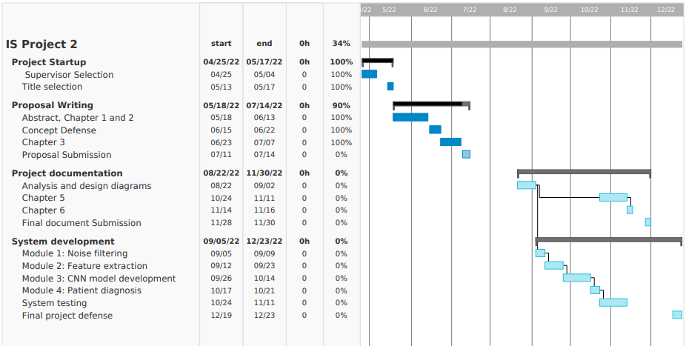

Appendix 1 Gantt Chart